Meeting 5/11/2021

- Welcome and Call to Order
- Updates from Chair
  - College of Arts and Architecture Summer Blood drive (June 15th) . Will be counted towards A&A Blood drive if you donate on that day at any location. Suggested #people for blood drive is only about 20 people this summer. Contacted digital media student's world campus, and they agreed they do not have time to work on it. If they are unable to help us with it, we will not have anything new to share, we will still have information to share.
  - Sustainability Council
    - Sustainability visit AA SAC - Diana will follow up with her to get Mihyun and/or Deb to visit this group (June?)
    - Council SAC member - will be voting on this with our next term of people.
  - A&A DEI Interviews
- Discussion
  - Staff Award for Outstanding Service (Jennifer Curry)
Dean Carpenter asked if the SAC could discuss and change the wording, if deemed necessary. https://sites.psu.edu/aainternal/dashboard/awards/
To clarify appropriate time period the award is designed to recognize, SAC members decided to eliminate the words “within the previous academic year” prior to bullet points (“Among those eligible” paragraph).
  - Events Consideration - Welcome Back outdoor event for the purpose of welcoming one another back (Diana Malcom)
      - Panera cookies & iced coffee/tea? Something cheaper and easier than ice cream (which requires refrigeration)
      - One hour FIKA style - afternoon coffee break
      - Date – August 16 (end of week prior to classes)
      - Committee to coordinate: Beth, Hope, Brendan
      - Location ideas for committee to consider. Outside event will mean that it will should be open to all F,S,S.
      - Will be budgeted this year (beginning July).

  - Listening Sessions (Sita Frederick) interested in getting connected to staff on campus (not just AA). If she provides some dates, can we put out an interest form or sign-up sheet with UPSAC. Brendan will reach out to her directly. Brendan suggested having her visit AASAC as well.
  - 2021-22 (Jennifer and Brendan)
    - Official rules is that each department has a voting member. Others may stay on board without voting, to stay aware of topics.
    - Have some leeway as to who is technically still on council.
    - Hope will stay on for another year, CPA 2nd rep.
    - Brendan added Judy King to teams.
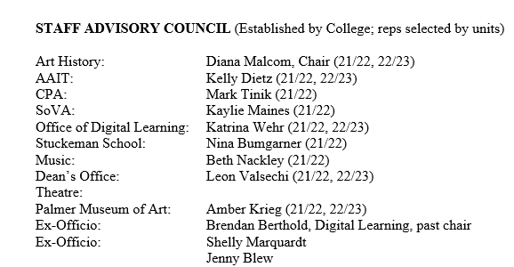
  - Review of 2020-21 conversations:
    - SAC role in RTW - nothing that we will be doing related to RTW.
    - Communities of Practice (Brendan) - Scheduling Groups has been set up; Brendan will work on setting up more conventional groups. In non-official capacity, he will continue to work on this to assist in our work.
    - For information: Digitizing materials - 2015-2021 documents are in teams; old binders with all documents are housed in Art History (240 Borland) currently.

Thanked Jen and Sheryl for being on the SAC team the past year.

Next Meeting June 8th, on Zoom. Will maintain digital meeting through August. Once we are in person, will need to have digital element for those who are working remotely. Jen and Diana can work on this.

