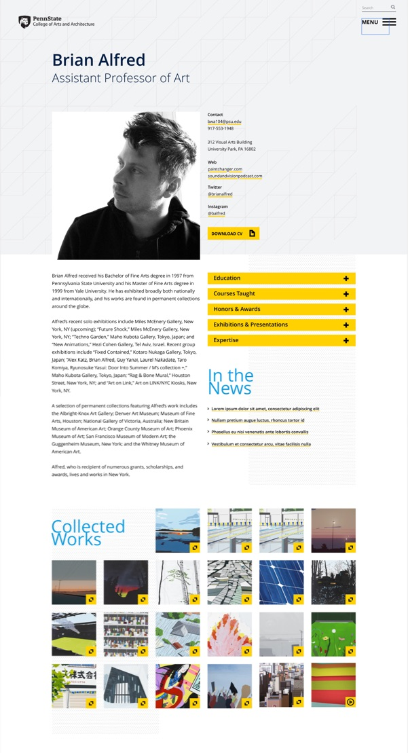 | FACULTY PROFILE TEMPLATE  Faculty profiles: https://arts.psu.edu/faculty/  The new website offers flexibility to showcase your work and scholarship in ways that may not have been possible on your previous unit site. This is a great opportunity to freshen your content, so, fill out this form, gather new high-quality images/videos of your work, and upload the lot of it.  Pick your cloud: Box, Drive, OneDrive, whatever… just complete this template, upload all images, plus a ‘captions’ document to a folder bearing your name then email a link to swt101@psu.edu. Make sure that I can view and download all files. I will contact you with any questions.

PERSONAL INFO/BIO
Name
Position/Title
Degree Programs in which you teach (not just home unit)
Email
Phone (office)
Office Address
Web links
Social media links  (if desired) | Instagram:  Facebook:  Twitter:  YouTube:  Vimeo:  LinkedIn:  ResearchGate:  Academia.edu:
Bio
(Length: 125–250 words)

PROFESSIONAL INFORMATION
This information will present in ‘accordion’ sections that open/close on click. If you do not have content in a given section, it will not appear on your page (there will be no empty sections).
Education
Courses Taught
Honors + Awards
Exhibitions + Productions
Publications + Presentations
Built Works
Service + Professional Affiliations
Research Expertise (free field, will eventually be tied to searchable ‘experts’ listing @ Research pillar)

IMAGES + VIDEOS
We need a professional portrait, images of your work, and YouTube/Vimeo links to your videos.
Profile picture (JPG preferred; 1080x1080px minimum resolution)
CV or other files (PDF)
Work Gallery (Up to 20 images and/or videos. Please provide a document with image/video captions; indicate filename: caption. 1080x1080px minimum resolution for images.)
Video links (Must be YouTube or Vimeo links; please add 1 per line in this table cell)

